La Mode



**About..**

Hellol I'm an extremely driven and creative
  
who is currently open for career opportunirre
  
back-end web developer in the Greater Seat

Full Stack Developer s as a front-end or Ile Area

I'm a recent graduate of Coding Dojo, a codil Bellevue. WA that teaches 3 full stacks in 3 r of learning new technologies very quickly, an for opportunities to further expand my skills *£*

developer

Continue reading

ng school located in months. I'm capable id am always looking a*n*d grow as a

|  |
| --- |
| LA MODE  **mit**  La Mode is an Ecommerce website for designee to market various clothing products Users are able to view the available garments. select their desired quantitly and compile a shopping cart ror making a final purchase |

Family Contacts



----

**401.•••■•**

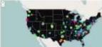

Five Eleven is a data visualization project bum on the Python software stack The application transforms the developer job-hunt into a more visual user friendly experience Based on location technology popularity and other vast data sets users may easily visualize the varying sizes and concentrations of the junior developer job market across the nation

Jayne Doe Master of shadows arid the Internet!

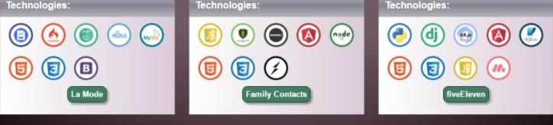

Technologies:

Technologies:

jdoe@gmalls corn I 206-555-1212 *javnedev* trz *Jayne-doedtweets C) javnedev*

Family Contacts is a free application for managing, sharing and visualizing your family relationships for both extended and immediate family As an essential feature Of the project. your log-In information determines who you can see and reveals how people are related to you

fiveEleven